
Atomic Peanuts
Project Bedroom
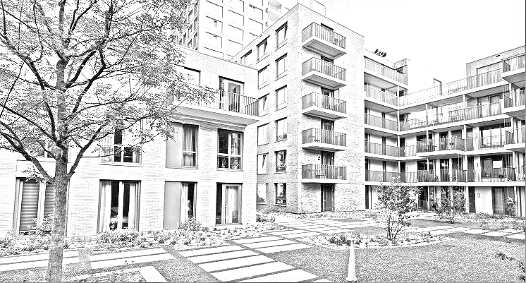

Jose Navarrete Carbonell (Project Leader) S.N: 3917533
Alexander Vartic (Group Member) S.N: 4030435
Menderes Saçli (Group Member) S.N: 3838439

Summary

Introduction…………………………………………………………………………….….……………….3
Environment Description……………………………………………………….………….………………3
Risk Factors………………………………………………………………………………………………3-4
Project Requirements……………………………………………………………..……….……………...4-5
Solution Proposed………………………………………………………...…………..……………………5
Solution Implemented………………………………………………………..…………………………..5-6
Recommendations…………………………………………………………………………………………7
Conclusion…………………………………………………………………………………………………7
Introduction
The project addresses some issues that Student Housing BV has presented us regarding the living situation in some of their residences. The objective of our software is to address this problems and give them a solution that will hopefully improve the situation drastically. With all this in mind, we created a software to be implemented in all of the residences. We created the software keeping in mind at all times the possibility of language barriers and other issues that might cause people to refuse certain tasks, for this reason, we tried to make our program as flexible and simple as possible.
In the following sections of this report, you will learn about what requirements were requested from us, what solutions we initially thought of and what our final implementation is and how it addresses the issues introduced to us by Student Housing BV.

Environment Description
The issues that the company is describing us are common issues in the environment of student houses. Due to the different nationalities, customs, behaviors, beliefs and even likes, it is very common for members of the residence to have conflicts with each other. Some of the conflicts we think are the main problem are: lack of communal groupwork, bad manners, lack of respect for housemates which includes throwing unapproved parties or even using items from housemates without permission, not paying items for public use…
Even if most of this conflicts may seem trivial, due to some of them there are students whose experience in the house might be disturbed or they may even be forced to move if those issues keep persisting, and if that was not possible due to the student’s economical or familial situation, it could even lead to further problems in the student’s mental health like depression, and for that reason they should be addressed immediately and effectively so they won’t happen again. We think that our app will give the manager of the houses the opportunity to have a better overview of the situation, with objective and real data that will hopefully improve the life quality of all the clients from Student Housing BV once our software is implemented into their residences.

Risk Factor
- Illness of a group member.
- Group member leaving the country.
- Group member quitting.
  - All group members are key to the development of the app, if one or multiple were to become unable to assist with it, it would mean a big drawback for the app.
- Lack of time.
  - Due to the dates of the project it is possible that lack of time will be a problem affecting the creation of the app.
- Huge change of plans.
  - A big change of plans would bring issues, which paired with the previous risk might prove catastrophic for our app.

Project Requirements
The problems that Student Housing BV disclosed to us from direct complaints from their clients are the following:
- Appointed persons not cleaning the shared facilities.
  - Fixed with a Tasks tab that will help to keep track of the different tasks.
- Groceries are not done or paid for shared items such as toilet paper, dish soap, etc.
  - Fixed with a Groceries tab that will help to keep track of the different items purchased and the amount of money owed by each user.
- Garbage disposal is not done on time
  - Fixed with a Tasks tab that will help to keep track of the different tasks.
- Unannounced parties, gatherings, etc.
  - Fixed with a Complaints tab that will allow users to anonymously place complaints against other members of the household.

All the requirements are explained with more depth in the Solutions Implemented part.

Solutions Proposed
We had multiple solutions proposed when the project was proposed to us in the first place, we will mention them in this part of the report.
First, we thought of creating a physical system with Arduino that worked with ID cards or fingerprint sensors that would keep track of who was in what part of the house, in order to see if they did or didn’t do the tasks. We scraped this option almost immediately due to the fact that it would require changes in the house (doors etc.), which would make it more expensive and it wouldn’t ensure that the students would be doing what they were required to do.
Then, we thought of an phone app that everyone would be able to open and simply place a complaint, however we saw that this limited the use of C# and that it would be too basic for the requirements and implementing any further improvements would require a substantial amount of time spent in investigation.
After that, we suggested a normal Visual Studio form app that would be connected via a simple network and would communicate via sending signals, we also wanted to create a login system so each person would get an individual experience, however even though our final solution Is similar to this, we scrapped this option due to the suggestion of using something similar to a network connection but that would also store information.
Finally, we decided to go for an divided in 2 different types of users (users and admins) that would store and retrieve information from an SQL server, this way every time the app is launched we will be able to maintain information and a full recovery will not be needed.

Solution Implemented
Our final solution consists of two (2) apps connected via an SQL server which will store and manage all the information related with each of the residences provided by Student Housing BV.
Each person will have access to an account which will direct them to a different type of app depending on which user they have, a normal or an admin user.
We wanted to create an app only accessible to the person managing the house, which is the Admin app. This app just mentioned will have control over the users themselves. It will have the power to create or delete users and to have an in depth overview of the complaints tab. This means that the Admin has access to a Complaint tab which contains who is the sender of the complaint. This was done with the aim of avoiding the complaint tab to become a secure way for students verbally abusing others.
The second app would be the users app, it gives access to all the functionalities that the app offers to the users from the house like, a list of the tasks to perform and who is in charge of performing them plus the chance of a button to place a complaint against someone not performing them properly, a list of the rules from the house, a tab to complain anonymously and a Statistics tab that will allow users to see how they are doing in the eyes of their housemates and a tab containing the complaints and who they were directed to.
Our app, just like any other software, suffers from some issues which we were not able to fix in time. Those issues are:

- The admin control panel only has control over users, not the app itself.
  - Initially, we wanted the admin to have power over everything and limit the power of the users to exclusively complaints and some shopping items addition, however we ended up switching into a more manageable but not optimal version in which the users have control over most things and the Admin can manage the students.
- Key generation required for registry.
  - This is not necessarily an issue but it can be considered one due to the extra time consumption. In order to register a user you need a Key to be generated manually, which means that every time a new student moves into one of the residences provided by Student Housing BV, the admin will have to manually create and provide the key.
- Tasks always given to a single user.
  - Our tasks tab is used to keep track of the amount of tasks available and the person who has to perform them, however, we decided that the tasks will all be done by one single user who will have to perform them all. This was decided due to the fact that some of the tasks are a matter of seconds, and we believed that it would be better to have a different person periodically. We are aware that this can be an issue if multiple tasks of long duration are added.
- Shared items Price of Item can’t be decimal.
  - For convenience sake we decided that the price from the items added would be rounded into an integer, this should not be a major issue, however it is something that could cause confusion in items with a very small price.
- Display/Statistics information.
  - Our statistics tab allows a user to see an overview of each of the students in the house, including whether that person is on duty, the amount of complaints placed against the person, the amount of times that people complained about his tasks not being done properly and the amount of times someone complained about an item not being paid. The first issue is that everyone has access to all the complaints, that can be annoying for some users due to their information being displayed to the public. Furthermore, the statistics don’t give any more information other than basic numbers.

Recommendation
We would like to strongly recommend for the app to receive some variations in the future to perfect it’s usability if some of the issues remain. Firstly, the Admin tab should have a lot more control over everything going on, having dates and times for every action performed by each of the users. This will give the administrator from the residence an easier time if a decision has to be taken against one of its residents. We also recommend a rework of the GUI since the one provided on base is not very appealing and might lead to confusion in some of the tabs.
Fixing our issue with the tasks in a way in which it’s more customizable by the users so they can decide themselves who is going to do what and when would also be recommendable, as mentioned above, our app currently only gives the chance of having a single user performing all the tasks.
Statistics displaying a more in depth view, allowing users to see things like, items for which money is owed, including date of purchase for additional clarity and also perhaps the chance to dispute a payment if they feel it is not fair for them because, for example, they are allergic to the food purchased and for that reason they could never enjoy the product.
Improving the registration system would also be ideal, as mentioned previously, our system is very manual, which shouldn’t be an issue in smaller residences but if we are talking about a building with dozens of students, having to control the in and out of users would become very fast an issue for the residence manager, and it might lead to confusion or further problems.
Conclusion
To sum up, our app solves all the requirements provided by Student Housing BV and we believe that as long as a series of basic rules are followed, the app will solve all the problems in the houses or at least give enough information about who is being problematic so the person in charge of the residence will be able to take action.

